**Shorthand with piano chords**

**(the Michela machine stenographic theory for English)**

**Paolo A. Michela Zucco & Fabio Angeloni**

(licensed under [CC BY-NC-SA 4.0 International](https://creativecommons.org/licenses/by-nc-sa/4.0/deed.it) 2019-2021) (Ver. 1.1.3)

DISCLAIMER: Please note this theory is still experimental. Informations are provided for personal use and research only. The authors make no warranties or guarantees for any particular result from application of this theory. The information contained in this document are not a substitute for professional and official English stenographic machine theories. The authors are not responsible for any direct, indirect, consequential, special, or other damages, including, but not limited to economic. All materials are included in good faith, the accuracy, validity, effectiveness, completeness, or usefulness of any information herein, as with any publication, can not be guaranteed.

**What is the Michela machine?**

The Michela system is an exceptionally fast typing method built on the use of a particular machine with a piano-style keyboard formed by 20 keys, 10 symmetrical keys for each hand. These two octaves correspond to two specific areas of a common musical keyboard: from D sharp to C major and from E major to C sharp. The Michela machine was invented towards the end of the nineteenth century and has currently been upgraded by the italian Senate to a digital version for the drafting of reports generated by parliamentary debates in the present day. With machine stenography it’s possible to type at oral speed and therefore transcribe any kind of speech exceptionally fast.

**The Michela English theory**

This Michela English theory, and its respective basic dictionary, was created by the authors for the purpose of extending the application of the Michela keyboard to the English language. It was drawn from the *Method for the English* ***l****anguage*,included in the machine’s 1878 American patent, and further enriched with the addition of more adaptations in order to make the system more suited in the field of digital transcription systems.

**A bit of history**

Antonio Michela Zucco was born in S. Giorgio Canavese on February 15th, 1815. After graduating from the Royal Albertina Academy in Turin, he dedicated himself to teaching, first as an elementary school teacher in numerous schools of the Canavese region and then as a high-school teacher in industrial design and architecture at the technical schools of Ivrea. Having always been a devout music lover, he simultaneously ​​conducted research on an idea that had always fascinated him: a universal alphabet solely constructed on phonic values, which would then be registered in the form of graphemes symbolizing a word. Such approach is then considered, for obvious reasons, analogous to musical writing for every kind of musical instrument. Convinced that «the sum of the phonic elements necessary for the formation of syllables needed for any language must necessarily be an ordered and limited whole», Michela Zucco succeeded in classifying such phonic elements and giving each a grapheme. Following this, he devised a mechanism to record these sounds synchronously to the speaker’s pace with notable accuracy. «The marvellous agility and spontaneity with which a skilful piano teacher can, even at first glance, read and generate a multitude of notes that are harmonically paired and played contemporarily, made me hypothesize that the sensory nerves that branch off from the human brain and reach the extremities of the hands, can, by sufficient exercise, become equally instinctive as those that control speech. By observing the material structure of each phonetic syllable produced, I conceived the aforementioned system by which the fleeting syllables composing a speech could swiftly be typed in unison with the movement of lips».

With such words the inventor illustrated the birth of the Michela machine, which obtained the Italian patent and several European patents in 1878, and the US patent in 1879. Michela Zucco was awarded at the Great Universal Exhibition taken place in Paris in 1878 (he was awarded the silver medal having refused to disclose the technical peculiarities of his invention), however, in 1881 he won the gold medal at the Milan Exposition and in Turin in 1884. During those years, the stenotelegraph Cassagnes was born in France, which allowed to transcribe speeches at a speed of 10,000 words per hour through the use of the Michela keyboard. Such agility was regarded as revolutionary at the time, considering that the ordinary telegraph only reached 500 words per hour. The Italian Senate adopted the system in 1880, becoming the first Parliament relying on the stenotype system for the drafting of legislative reports in the world.

Meanwhile, after having retired from teaching, Professor Michela Zucco dedicated himself to the completion of the *Universal Hand Phonographic System* for several years, which was then published in 1885 and divulged by the inventor to the “Filotecnica Torinese” society(*).

Moreover, he also progressed in his mathematical and geometrical studies. Unfortunately, only two of his reports on *Characteristic properties common to the periphery of the circle and the perimeter of the equivalent square* and *Proposal of an invariable relationship between periphery and radius, demonstrated with five theorems* have been found and are available today. Lastly, in the midst of his studies and at the peak of his achievements, Professor Michela was awarded the silver medal for scholastic merit by the Ministry of public education and nominated Knight of the Mauritian Order by the King of Italy. He subsequently passed away on December 1886.

___________________________________

(*) The International phonetic association was founded in 1886 in Paris, and the first publications on the International phonetic alphabet were issued in 1888. As Giulia Torregrossa argues in her article *Michela Phonographic and Stenotypical Sign*, published in the magazine *Specialization* by Accademia Aliprandi, “There are legitimate reasons to infer that the table of the phonetic joint may have been a brilliant anticipation of the International phonetic alphabet (IPA). Some recurring elements include the classification of vowels as frontal, central and posterior, based on the tongue’s position; the way in which the letters representing two sounds are considered (such as a voiced and unvoiced *z* or *x*); the graphemes chosen to transcribe the phonemes (...) which derived from the modification of the structure of existing letters or from the addition of diacritical marks. In fact, the aforementioned 1887 phonographic manual was written by Professor Michela’s students, who reveal that the theory supporting the phonographic palette took about 47 years to complete. Antonio Michela’s theory on the phonetic classification of consonants and vowels is therefore likely to have anticipated the one that endorsed the International phonetic alphabet and, on occasion of the Michela phonostenographic exhibition at the 1878 Paris universal exposition, the professor may have illustrated the phonographic theory behind it, inspiring colleagues from beyond the Alps”.

**Current situation**

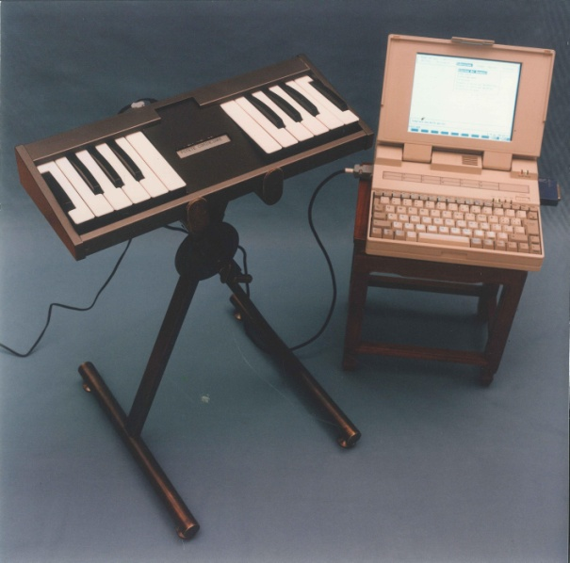 The Michela keyboard essentially maintained its function and aesthetic for over a century, until a more avant-garde version came into use in 1974, followed by an electronic version in 1982(1). The first Michela CAT compatible (Tecnidata) was presented in 1990 and a MIDI version (Fatar) was made in 2003, using the same protocol used for musical keyboards, which made the production process significantly cheaper(2).

The Tecnidata model (circa 1990)

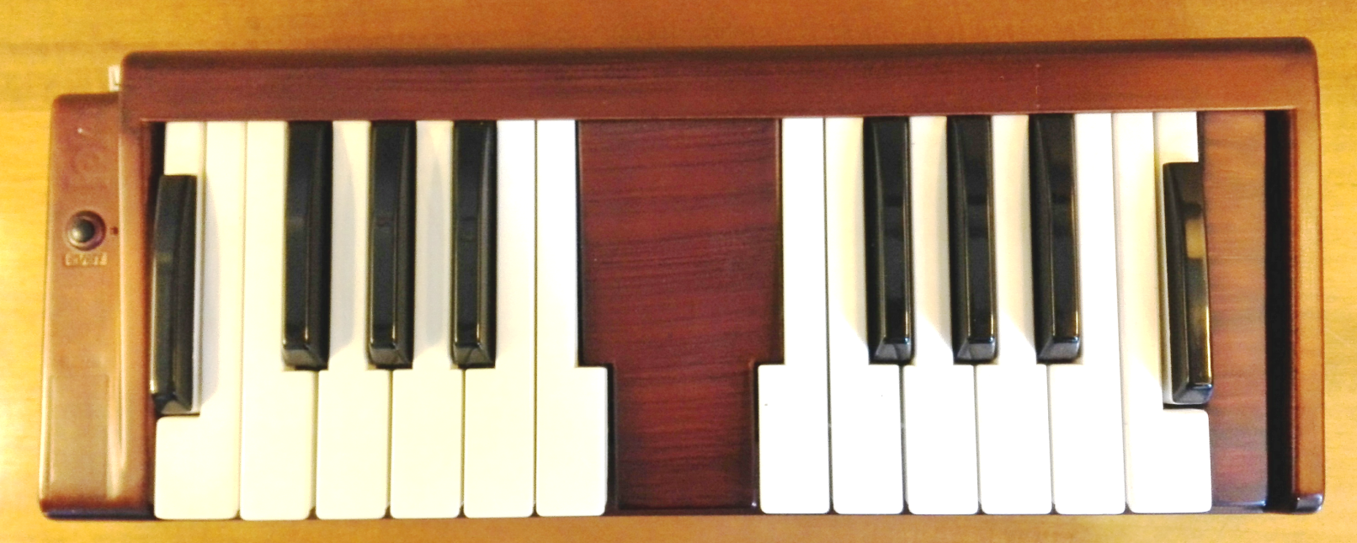

The Fatar-Midi keyboard (circa 2002)

___________________________________

(1)With this keyboard, Senate stenographers obtained four international titles at the international stenography championships of 1979, 1983, 1985, and 1995, with a maximum writing speed of 500 syllables per minute, as well as all Italian titles in the years in which they participated to the national speed contests (1977-1996)**.**

(2) With this model, a young Senate stenographer achieved the highest stenotyping speed among all competitors at Intersteno international championships in 2009, and in 2015, she set the European speed record to 471 syllables per minute.

**The phonetic writing**

The Michela system is phonetic, so words are usually written not following their orthography but their sound. Just in some cases (disambiguation between same sounding entries) this rule is not followed and words are written in a more adherent way to their spelling1.

1) For a better understanding of the Michela system it is advisable to first learn the Midi4Text system, as this is a good introduction to it: many phonic combinations (with the exception of the vowels of the 3rd Series) are in fact the same between the two systems.

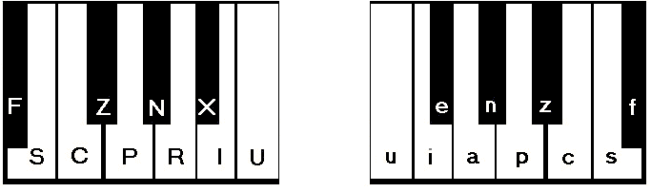

As it has been said, the Michela keyboard uses two portions of 10 keys of a common musical keyboard. This layout and the assignment of the various keys to the different fingers of the hand has been carefully studied by the inventor to achieve maximum efficiency and speed of writing by limiting the movements of the fingers as much as possible.(*)

By using the Michela keyboard, it’s possible to write syllables phonetically, as if they were piano chords. The sound of a syllable is, in fact, generated by pressing one or more keys contemporarily with both hands. Each syllable is composed of a set of sounds (phonemes), which the inventor classified into four phonic elements: 1st phonic element (initial sound); 2nd phonic element (subsequent to the 1st); 3rd main phonic element (tonic vowel); 4th phonic element (final sound). For example, the syllable “SI” is made up of the initial sound “S” and the main vowel sound «I». In the word “traction”, the syllable “TRAC” comprises the initial “T” sound, the following sound “R”, the main vowel sound “A”, and the concluding sound “C”, while the syllable “TION” is composed of the initial “T” sound, the subsequent “I” sound, the main vowel “O” and the closing sound «N».

Such reoccurring fragmentation of the syllable in segments, or “series”, allows for the deconstruction into the four parts a syllable can ideally be divided into. As previously stated, the keyboard consists of two distinct regions enclosing 10 keys, one for each hand. Two specific keys are assigned to each finger (except in the case of some extended combinations used experimentally), which not to be pressed simultaneously, excluding the thumbs.

___________________________________

**Michela system keyboard layout**

The Michela keyboard’s layout is almost entirely symmetrical and specular, as seen above: 80 percent of the sounds in the left keyboard are repeated and mirrored in the right keyboard with the same combinations. Such structure greatly facilitates the memorization of the different sounds. Each key represents a different phoneme and is associated to a different grapheme, however, the individual sounds that can be generated from the four series are not limited to those corresponding to the 20 keys: numerous other sounds can be created by combining different keys, likewise to constructing chords on a piano.

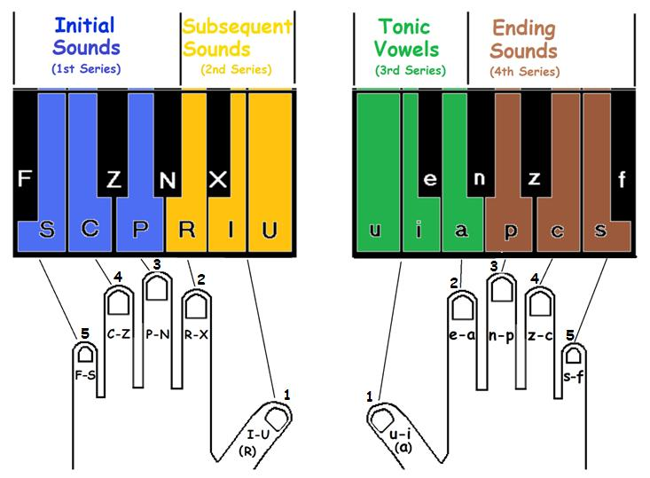

**Table of sounds**

**1st (and 4th) Series**

|  |  |  |  |  |  |  |  |  |  |  |  |  |  |  |  |  |  |  |  |  |  |  |  |  |  |  |  |  |  |  |  |  |  |  |  |  |  |  |  |  |  |  |  |  |  |  |  |  |  |  |  |  |  |  |  |  |  |  |  |  |  |  |  |  |  |  |  |  |  |  |  |  |  |  |  |  |  |  |  |
| --- | --- | --- | --- | --- | --- | --- | --- | --- | --- | --- | --- | --- | --- | --- | --- | --- | --- | --- | --- | --- | --- | --- | --- | --- | --- | --- | --- | --- | --- | --- | --- | --- | --- | --- | --- | --- | --- | --- | --- | --- | --- | --- | --- | --- | --- | --- | --- | --- | --- | --- | --- | --- | --- | --- | --- | --- | --- | --- | --- | --- | --- | --- | --- | --- | --- | --- | --- | --- | --- | --- | --- | --- | --- | --- | --- | --- | --- | --- | --- |
| |  |  |  | | --- | --- | --- | | F (f) | f, ph, gh | *f*ather, *f*ox, pro*ph*et, enough, cough | | S (s) | s (unvoiced)1 | son, po*ss*e*ss*ion, le*ss,* thi*s* | | C (c) | sh, ti | *sh*e, wi*sh*, depreda*ti*on4 | | FC (cf) | h, ending st | *h*ouse*,* have, horse, *h*at, be*h*ind, u*h*, be*st,* cre*st* | | SC (cs) | v | *v*ine, *v*iolent | | Z (z) | s (voiced)1, z | u*s*age, u*s*eful, hou*s*e, is, the*s*e,re*s*ume, hori*z*on, *z*apping | | FZ (zf) | th (digraph) | *th*e,bro*th*er, ear*th*, weal*th* | | SZ (zs) (3) | rd  (ord, art) | o*rd*er, a*rt*work, ne*rd*, cho*rd* | | P (p) | p | *p*eo*p*le, re*p*tile, *p*a*p*er | | FP (pf) | t | *t*rifle, gen*t*le, *t*rade | | SP (ps) | ch (c soft)2 | whi*ch*, ea*ch*  *ch*amber, pea*ch* | | CP (pc) | c (hard)2, k, q | be*c*ause, *c*on*q*uest,  a*cq*uired*, k*ing, bla*ck* | | FCP (pcf) | b | tri*b*ute, *b*ecause | | SCP (pcs) | d | *d*ear, *d*epre*d*ate, ma*d*e, Ne*d* | | |  |  |  | | --- | --- | --- | | ZP (pz) | j, g (soft)2 | *g*iant, just *g*enerous, journey, pa*g*e | | FZP (pzf) | g (hard)(2)  shun sound | *g*reen, *g*eese, *g*old, game, whi*g,* pa*ssion* | | SZP (pzs) | m | *m*ore*, m*useu*m* | | N (n) | n | *n*iece, *n*oo*n*, *n*o*n*e | | FN (nf) | nd | i*nd*ustry, fou*nd*, bo*nd, under* | | SN (ns) | ng  (eng ing) | writi*ng,* ki*ng,* e*ng*lish, i*ng*rain, | | CN (nc) | w | *w*ater, *w*ine, *w*olf, stra*w*, bo*w,* | | FCN (ncf) | r | *r*efuse, *r*eimburse,  fa*r,* dea*r* | | SCN (ncs) | l | *l*ance, *l*iteral,  be*ll* | | ZN (nz) | y | *y*ester*, y*et*, y*es*,* bo*y,* gre*y,* ma*y* | | FZN (nzf) | nt (n't)  (blend) | *int*ense, *ent*irere*nt,* fo*nt,* ca*n't,* do*n't* | | SZN (nzs) | x, kshun snd. | xeno, e*x*it, ma*x*im, fo*x,*  o*x*en, a*ction* | |

1) With several exceptions, the S is unvoiced at the start of a word (Spain), when is double (glass), and before a voiceless consonant (ask); the S is instead usually voiced between two vowels (busy) and before a voiced consonant not at the start of the word (husband).

2) There are two different sounds for the consonant "c" and "g": a hard sound (cup, class, rack, great, good, rag), and a soft sound (city, receive, cell, chime, chat, large, general, giant, just) which are differentiated being the Michela a phonetic system based on sounds.

3) In the original English layout this combination was assigned to the Z sound («ʣ» and «ʦ» IPA sounds). Considering that in English there is really a soft difference between the z (dz) and the voiced s (z) word sounds, it has been decided to write both sounds with the z key and to use the z (sz) combination for the blend «rd».

4) The ending "shun" sound can also be written using the «x» sound in the 4th series.

**2nd series 3rd series**

|  |  |  |  |  |  |  |  |  |  |  |  |  |  |  |  |  |  |  |  |  |  |  |  |  |  |  |  |  |  |  |  |  |  |  |  |  |  |  |  |  |  |  |  |  |  |  |  |  |  |  |  |  |  |  |  |  |  |  |  |  |  |  |  |  |  |  |  |  |  |  |  |  |  |  |  |  |  |  |  |
| --- | --- | --- | --- | --- | --- | --- | --- | --- | --- | --- | --- | --- | --- | --- | --- | --- | --- | --- | --- | --- | --- | --- | --- | --- | --- | --- | --- | --- | --- | --- | --- | --- | --- | --- | --- | --- | --- | --- | --- | --- | --- | --- | --- | --- | --- | --- | --- | --- | --- | --- | --- | --- | --- | --- | --- | --- | --- | --- | --- | --- | --- | --- | --- | --- | --- | --- | --- | --- | --- | --- | --- | --- | --- | --- | --- | --- | --- | --- | --- |
| |  |  |  | | --- | --- | --- | | R | r | g*r*eat, t*r*ifle, g*r*adual,  sc*r*ape | | X | s | ob*s*erve, gip*s*y | | I | i | ital*i*an, sold*i*er | | RI | l | g*l*ass, cog*l*ove,  c*l*austral, c*l*ew,  p*l*ummer | | XI* | w, f | d*w*arf*,* d*w*ell*,* t*w*elve | | U | u, (undo) | habit*u*al, grad*u*al | | RU | m | at*m*osphere, arith*m*etic, govern*m*ent | | XU | n | garde*n*er | | UI* | p, b | s*p*ort | | RIU* | t, d | s*t*ation | | XIU* | c, g | s*c*arf | | RX | (disamb.) |  | | RXI | (fingrspell.  orthogh.) |  |  |  |  |  | | --- | --- | --- | | a | a (short) | *a*lg*e*bra, *a*lcove, *a*ft*e*r, breakfast | | e | e (short) | f*e*deral, *e*pic | | i | i (short) | f*i*ddle, f*i*tly, | | ie | o (short) | G*o*d, f*o*rtunate | | u | u (short) | *u*mbrella, h*u*sband,  b*u*t, | | ua | a (long) | *a*ge, g*a*te, n*a*me | | ue | e (long) | f*ee*l, n*ee*d, w*ee*k, thr*ee* | | ui | i (long) | w*i*ne, *I*, wh*y*, m*y*self, s*i*gn, b*y*te, m*i*crophone | | uie | o (long) | h*o*me, kn*o*w, l*o*cal | | uia | u (long) | *u*sage, *u*seful, m*u*sic, h*u*man | | ia | ow, ou | *ou*r, with*ou*t, th*ou*, y*ou*r, f*ou*nd, sound | | ea | ea, ae  (disamb.) | br*ea*d, l*ea*d, b*ea*t, r*ea*d, f*ea*st | | iea | oa, oo  (disamb.) | l*oa*d, br*oa*d, bl*oo*m | |  |

(*) These combinations are used to represent the main similar phonemes; some of them in English are mainly used for abbreviations.

**Inter-serial**

**1st+2nd series 2nd+3rd series**

|  |  |  |  |
| --- | --- | --- | --- |
| FC | R | initial STR | *str*eam, *str*etch |
| FC | RI | initial SPL | *spl*ash, *spl*it |
| FC | IU | initial SPR | *spr*ay, *spri*nt |
| FC | XIU | initial SCR | *scr*ape, *scr*oll |

|  |  |  |  |
| --- | --- | --- | --- |
| U | u | middle AW, AU | d*aw*n, l*au*d |
| I | i | middle OY, OI | enj*oy*s, ch*oi*r |

Such sounds, although seemingly limited, encompass the syllables needed to compose any word. For example, the word “Michela” is formed by the syllables “mi”, “che” and “la”. The first will be written by pressing the “M” key of the 1st Series simultaneously with the “i” of the 3rd Series. The second syllable will be built by pressing the hard 1st Series “C” key simultaneously with the “e” of the 3rd Series. Lastly, the “L” key of the 1st Series will be pressed together with the “a” of the 3rd Series.

F S C Z P N R X I U u i e a n p z c s f

S Z P i MI

C P e CHE

SC N a LA

C N R i p f WRIT

n s ING

F P e c f TEST

To achieve greater speed and reduce writing fatigue, however, it’s preferable to abbreviate the words, following the rules found below (in brackets the phonetic translation, so-called pseudosteno).

F S C Z P N R XI U u i e a n p z c s f

S Z z THIS IS (th-z)

a n AN (an)

S Z N n cs EXAMPLE (x-l)

i e f OF (of)

C N R i n f WRITING (wring)

C N WITH (w-)

F C P XI u e p z f ABBREVIATIONS (bveetion)

s (^s)

**ILLUSTRATIVE LESSONS**

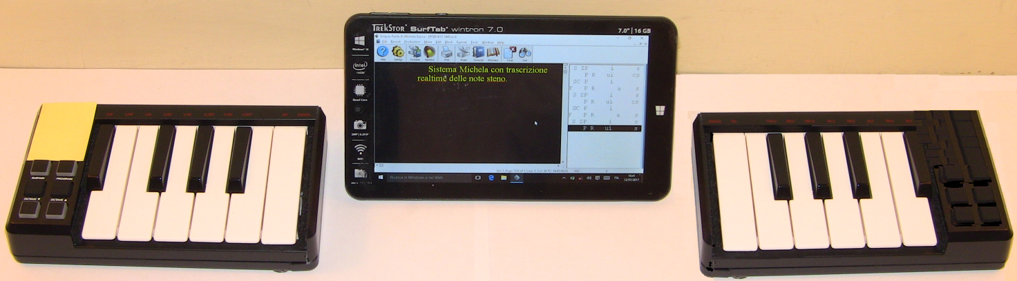

Split keyboard prototype

**Lesson I**

*(The numbers on the keys correspond to the fingers to be used according to the diagram shown in the layout)*

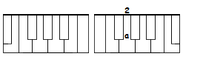

Key **a** (3rd Series) *Sound*: A (short)

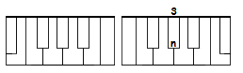

Key **n** (4th Series) *Sound*: ending N

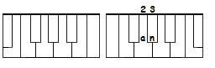

**words**: AN (an)

___________________________________

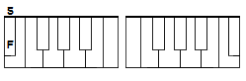

Key **F** (1st Series) *Sound*: initial F

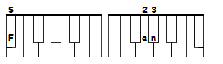

**words**: FAN (Fan)

___________________________________

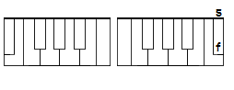

Key **f** (4th Series) *Sound*: ending F

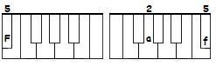

**words**: FAFF (Faf)

___________________________________

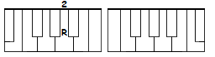Key **R** (2nd Series) *Sound*: middle R

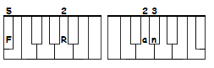

**words**: FRAN (FRan)

___________________________________

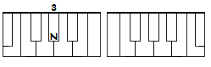

Key **N** (1st Series) *Sound*: initial N

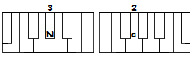

**words**: NANA (Na/Na)

___________________________________

Keys **SCP** (1st Series) *Sound*: init./end. D keys **pcs** (1st Series)

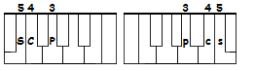

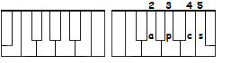

**words**: ADD (apcs)

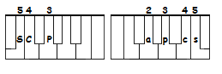

DAD (SCPapcs)

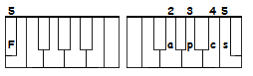

FAD (Fapcs)

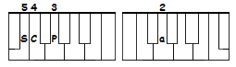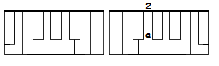 ADA (a/SCPa)

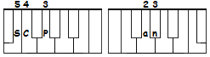

DAN (SCPan)

Note: As a generale rule, the syllable’s initial sound is always written in the 1st Series, except for the syllables beginning with a vowel, which must always be written in the 3rd Series.

___________________________________

**Inflected endings**

Inflected endings are a category of suffixes linked to words to indicate their tense, number, possesives and contractions. The most recurring inflected endings are -s, -d and -ing, which are generally added to the given word whith a separate stroke.

**The inflected ending /-d**

A separate /-d stroke is used to form the past tense of a word. In some cases, the past tense form only adds a “d” to the root of the word (use+/-d = used), an “ed” (park+/-d = parked), or a double final consonant (stop+/-d =stopped). Said variations are usually managed by the translation software. Inflected endings are usually symbolized by the same ^ charachter used for suffixes in the main dictionary. In the Michela theory, the inflected ending –d is written with a separate stroke, with the d combination in the 4th Series(*).

^ed = pcs

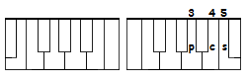

ADDED (apcs/pcs)

**Sentences**: A Dad. Nana Ada. A Dad fan. A faff. A Dad fad.

* The inflected endings must always be written with a separate stroke, except for special cases where is possible toinsert their sound in the same stroke of the root words (in the IV Series) or, as we will see later, in some cases also in the 2nd Series.

### Lesson II

**FP** (1st Series) *Sound*: initial and final T **pf** (4th Series)

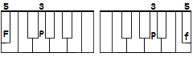

FAT (Fapf), DAT (SCPapf), TAN (FPan), AT (apf), FRAT (FRapf).

___________________________________

**P** (1st Series) *Sound*: initial and final P **p** (4th Series)

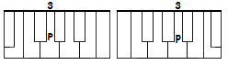

PAT (Papf), PAD (Papcs), TAP (FPap), PAN (Pan), NAP (Nap), PAPA (Pa/Pa)

___________________________________

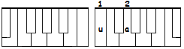

**ua** (3rd Series) *Sound*: A (long)

A (ua), PRAY (PRua), FRAY (FRua), PAIN (Puan)(*), DRAIN (SCPRuan), PAID (Puapcs), PAY (Pua), TRAIN (FPRuan), TRADE (FPRuapcs), DAY (SCPua), AFRAID (a/FRuapcs), ATE (uapf), DATE (SCPuapf).

*To differentiate soundalike with AI sound (e.g. pain/pane), the long A will be used for words with the ai spelling and the combination "ea" (V lesson) for the other word. If the conflict concerns two words, one of which without the ai spelling and the other with the ea spelling, the combination "ea" will be used to differentiate the latter (e.g. grate/great).

___________________________________

**Abbreviations**

Although it’s possible to write words phonetically using a stenographic keyboard, numerous abbreviations are used, particularly for the most recurrent words or phrases. For this reason, at the end of each lesson will be showed some abbreviations made for the sounds illustrated (a more complete list of abbreviations can be found in the appendix).

**Briefs**

a = ua

in = N

of = f

do = SCP

it = FP

not = Npf

are = R

for = FR

F = if

perfect = Pf

after = Fpf

**Sentences**

A fat dad. = ua Fapf SCPapcs

Add fat in a pan. = an apcs f a Pan

A trade of pain. = ua FPRuapcs f Puan

A paid train. = ua Puapcs (or Pui/pcs) FPRuan

A pray of a day. = ua PRua f a SCPua

A drain in a train. = ua SCPRuan N ua FPRuan

**Lesson III**

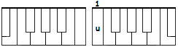

Key **u** (3rd Series) *Sound*: U (short)

PUT (Pupf), PUP (Pup), PUN (Pun), UP (up), FUN (Fun), NUT (Nupf), NUN (Nun).

___________________________________

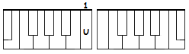

Key **U** (2nd Series) *Sound*: middle U/undo

DUAD (SCPUapcs)(*).

undo (delete last stroke): Pa/Pn/U/Pa = papa.

* As we will see later, the 2nd Series U is also used in some cases to represent the OY and AW diphtongsounds.

___________________________________

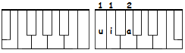

Key**s uia** key (3rd Series) *Sound*: U (long)(*)

DUE (SCPuia), YOU'D (uiapcs), TUNE (FPuian), TUNA (FPuia/Na), FEW (Fuia), FRUIT (FRuiapf), KNEW (Nuia).

*This combination, which requires the keys i and u of the 3rd Series to be simultaneously lowered, will be carried out by pressing the right hand thumb placed in a transversal position above said keys. The same indication applies to the examples found below, where the keys IU or ui must be pressed simultaneously in the 2nd and 3rd Series.

___________________________________

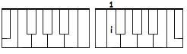

Key **i** (3rd Series) *Sound*: I (short)

PIN (Pin), DADDY (SCPa/SCPi), FIN (Fin), TIP (FPip), DIN (SCPin), PUPPY (Pup/Pi), PUNY (Puia/Ni).

___________________________________

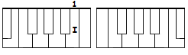

Key **I** (2nd Series)*Sound*: middle I

TIA (FPIa), PIA (PIa), NIA (NIa), DIANE (SCPIan), FIANCÉ (FIan/Sua).

___________________________________

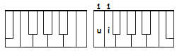

Keys **ui** (3rd Series) *Sound*: I (long)

EYE (ui), TIE (FPui), TRY (FPRui), PINE (Puin), NINE (Nuin), TYPE (FPuip), TINY (FPui/Ni), DRY (SCPRui), DIET (SCPuipf), TIGHT (FPuipf), FRIGHT (FRuipf), PIPE (Puip), PIETY (Pui/FPi), FINE (Fuin), TYPED (FPuip/pcs), UNIFY (uian/Fui), SIGHT (Suipf), TIDE (FPuipcs), FRY (FRui), TRIED (FPRuipcs)(*), FRIED (FRuipcs)(*).

*In these cases the inflected ending can be added in the 4th Series without generating conflicts.

___________________________________

**briefs**

union = uian

output = Puiapf

u = you

I = I

new = Nu

few = Fu

any = Ni

did = SCPi

**Sentences**: A dry eye. Do it fine. A tiny puppy. A fine fiancé. I paid for a day. A fine diet pie for Daddy. You typed pine not(*) nine.

*Some of the words in the sentences could use briefs introduced in previous lessons (e.g. not = Npf).

**Lesson IV**

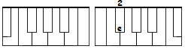

Key **e** (3rd Series) *Sound*: E (short)

TEDDY (FPepcs/SCPi), NED (Nepcs), PET (Pepf), PETRIFIED (Pe/FPRI/Fuipcs), TEPID (FPep/ipcs), FETID (Fepf/ipcs), FRET (FRepf), FRED (FRepcs), PEN (Pen), TEN (FPen), FETE (Fepf), NET (Nepf).

___________________________________

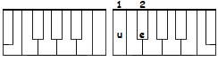

Keys **ue** (3rd Series) *Sound*: E (long)

PETE (Puepf), NEET (Nuepf), NEED (Nuepcs), NEEDED, (Nuepcs/pcs), DEED (SCPuepcs), DEAN (SCPuen), FEED (Fuepcs), FEEDED, (Fuepcs/pcs), TEEN (FPuen), TEENY (FPue/Ni), TREAT (FPRuepf), TREATED (FPRuepf/pcs), TREATY (FPRue/FPi), DINA (SCPue/Na).

___________________________________

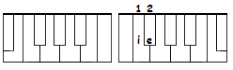

Keys **ie** (3rd Series) *Sound*: O (short)

TO (FPie), ON (ien), DOT (SCPiepf), NOT (Niepf), DOTTED (SCPiepf/pcs), POT (Piepf), PRO (PRie), PROP (PRiep), OPEN (ie/Pen).

___________________________________

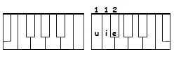Keys **uie** (3rd Series) *Sound*: O (long)

NOTE (Nuiepf), NOTEPAD (Nuiepf/Papcs), NOTATE (Nuie/FPuapf), POTATO (Puie/FPuapf), DIODE (SCPui/uiepcs), NOD (Niepcs), NODE (Nuiepcs), NODDED (Niepcs/pcs), FOOD (Fuiepcs), NEUTRON (Nuie/FPRien), DUO (SCPUuie).

___________________________________

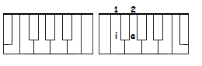

Keys **ia** (3rd Series) *Sounds:* OW or OU

TOW (FPia), TOWN (FPian), OUT (iapf), PROUD (PRiapcs).

___________________________________

Keys **FC** (1st Series) *Sound:* in. H/end. H, ST (blend) **cf** (4th Series)

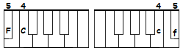

HE (FCe), HOT (FCiepf), HIT (FCipf), HAT (FCapf), HATE (FCuapf), HATRED (FCua/FPRepcs), HEN (FCen), HAPPEN (FCap/n), HAPPENED (FCap/Npcs), HENNA (FCen/Na), HIP (FCip), HAD (FCapcs), HAPPY (FCap/i), HIDE (FCuipcs), AH (RXacf), OH (iecf), EH(1) (RXecf), NUH-HUH (Nucf/FCu), FEST (Fecf), NEST (Necf), FAST (Facf), PAST (Pacf), TRUST (FPRucf), TEST (FPecf)

1) As we will see, the "RX" spelling disambiguator is used to avoid conflicts with other briefs or spelled words (e.g. «est»).

___________________________________

**Special inter-series combination**

keys **FCR** (1st and 2nd Series)*Sound*: initial STR (blend)(*)

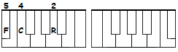

STREET (FCRuepf), STRIPE (FCRuip), STRESS (FCRes), STRAP (FCRap), STRAIT (FCRuapf), STRIDE (FCRuipcs), STRIFE (FCRuif).

*The initial ST sound (without the consonant "R", like in "stare") will instead be written with the unvoiced S key in 1st Series and the combination T/D in 2nd Series which will be illustrated later.

___________________________________

**Briefs**

happen = FCap

had = FC

open = uiep

FCRa = extra

extraordinary = FCRiepcs

he = e

from = FRie

**Prefixes and Suffixes(*)**

a^ = a/

extra-^ = FCR/

pro^ =PRie/

^en =/n

**Punctuation**

{.} (full stop) = nz

*In stenography, prefixes and suffixes are word parts which are normally written with a separate stroke (in some cases they can also be folde in the same stroke of the root word) and are used to write compound words (eg proactive = pro + active; interactive = inter + active; lighten = light + en; fundamental = fundament + al). The translation software links them to the next or previous word, respectively, if necessary correcting the syntax of the word. Using prefixes and suffixes reduces the size of the main dictionary because many words can be written simply by adding a prefix or a suffix to a given root without putting them in the dictionary.

**Sentences**: Fred noted a hen in a pot. Pete needed a potato to feed a hen. A diode fried in a stress test. I do not need a tepid food. Ned on a train nodded to Dan. He ate a fetid treated fruit. Daddy needed a pen not a notepad. Ada had petrified for fright. Dina and Dan are out of town.

**Lesson V**

keys **S** (1st e 4th Series) *Sound*: in./end. S (unvoiced)\***s**(4th Series)

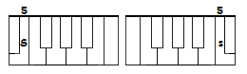

SAT (Sapf), SO (Sie), SON (Sien), SAD (Sapcs), SAID (Suapcs), DOS (SCPies), NICE (Nuis), CEASE (Sues), SEE (Sue), SEES (Suez), SEAT (Suepf), ASSET (as/epf), SAD (Sapcs), SENATE (Sen/Uapf), DESIGN (SCPe/Suin), SUNDAY (Sun/SCPua), ESSAY (es/Sua), FACE (Fuas), INSIDE (in/Suipcs), PASS (Pas), PASSED (Pas/pcs), SOCIETY (Sie/Sui/FPui or Suiepf), PRODUCE (PRie/SCPuias).

* With several exceptions, the S is unvoiced at the start of a word (Spain), when is double (glass), and before a voiceless consonant (ask); the S is instead usually voiced between two vowels (busy) and before a voiced consonant not at the start of the word (husband).

___________________________________

keys **Z** (1st Series) *Sounds:in./end.*  S (voiced), Z **z**(4th Series)

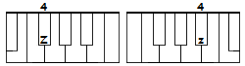

DOES (SCPiez), USE (uiaz), USED (uiaz/pcs), HESITATE (FCez/FPuapf), PROSE (PRuiez), ZAP (Zap), ZANE (Zuan), ZOO (Zuia), ZONE (Zuien), OZONE (uiez/uien), HIS (FCiz), HAS (FCaz), AS (az), NEWS (Nuiaz).

___________________________________

Keys **ea\*** (3rd Series) *Sounds*: ea or ae (spell. disambiguator)/blank space

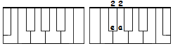

*Sound ea or ae*: cheap = CPeap; CREATE = CPReapf; PEACE = Peas; SEA (Sea), AFRAID (a/FReapcs).

*Blank space*: Nuh-huh = Nucf/FCu; nuh*[space]*huh = Nucf/ea/FCu.

* This combination is made by rotating the thumb under the index finger, similarly to what happens with the piano keyboard with the so-called "thumb passage". A similar indication applies to the cases, described below, in which the keys R and X must be lowered in 2nd Series. The combination "ea" in addition to being used as a disambiguator for words with a long A spelling is also used in some abbreviations to indicate both the median vowel and the final vowel (eg: happy = FCeap)

___________________________________

**briefs**

is = Z

data = SCPeapf

happy = FCeap

afraid = FReapcs

he is = FCez

it is = FPz

its = FPs

**inflected endings**

^s = /s

^'s = /ues

**punctuation**

{^'^} (apostrophe) = ue

**prefixes and suffixes**

^ness = Ns

NEEDS (Nuepcs/s), PINES (Puin/s), FRUITS (FRuiapf/s). FRED'S (FRepcs/eas), SADNESS (Sapcs/Ns), HAPPYNESS (FCeap/Ns).

He needs happyness. A hen tried to escape and hit a net. His son needed a pen. Fred feeds a hen on a seat. Oh is a nice zone. He is afraid of us. His son is afraid of his dean. Zane had hated DOS and hesitated to use it for his essay. Diane's cat has a nice face. His society has ceased to produce it.

### Lesson VI

key **C** (1st Series) *Sound*:in./end. SH (digraph) **c** (4th Series)

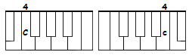

ASH (ac), CASH (CPac), SHUT (Cupf), SHOT (Ciepf), SHOE (Cuia), SHIN (Cin), SUSHI (Su/Ci), SHIP (Cip), SHE (Ce), SHED (Cepcs), SHOP (Ciep), TRASH (FPRac), PUSH (PUc), FISH (Fic), CHEF (Cef), SESSION (Sec/ien), SHOULD (Cupcs), ISSUE (ic/uia).

___________________________________

keys **CP** (1st Series) *Sounds*:in./end. C (hard), K, Q **pc** (4th Series)

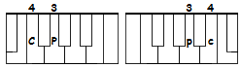

CUP (CPun), COP (CPien), KEN (CPen), CON (CPien), TUCK (FPupc), (CPupf), QUEUE (CPuia), crack (CPRapc), TICKET (FPipc/epf), CHRONIC (CPRien/ipc), QUAD (CPUapcs), KISS, (CPis), SEEK, (Suipc), CHRIS (CPRis), KIT (CPipf), KEY (CPue), KICK (CPipc), TRICK (FPRipc), TRUCK (FPRupc), SHOCK (Ciepc), HACK (FCapc), CRITIC (CPRipf/ipc), ESCAPE (es/CPuap), FOCUS (Fuie/CPus), CRITICIZE (CPRipf/Suiaz), CRITICIZED (CPRipf/Suiaz/pcs) COOK (CPuiepc), COOKED (CPuiepc/pcs), CRUDE (CPRuiepcs), CRUSH (CPRuc), TRACK (FPRapc), CRASH (CPRac), FAKE (Fuapc), FRANK (FRan/pc)(*).

*Some consonant combinations are not present in the 4th Series, like the word ending "NK". These word endings, which will better described in Lesson XVII, are usually written putting the final character in a separate stroke. As we'll see, in some cases is also possible to anticipate in the 2nd Series the first consonant sound of the word ending (eg. dark = SCPRapc).

___________________________________

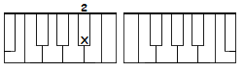Key **X** (2nd Series) *Sound* middle S

PSICHE (PXuipc), PSYCHIC (PXui/CPipc), PSYCHIATRIC (PXuipc/TRipc) PSITTACOSIS (PXipf FPa CPie Sis), SEPSIS (SE PXis), (PEPSI (Pe PXi)(*).

** The middle S sound, can be profitably used for a series of abbreviations by eliminating the intermediate vowel (position = PXicf, passed = PXepcs, possession = PXecf) and also, when this does not create conflicts, to indicate the final S of the plurals in the same stroke (cups = CPXup, cats = CPXapf, critics = CRipf / Xipc).

___________________________________

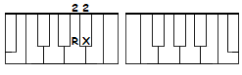

Keys **RX** (2nd Series) *Spelling disambiguator(*)*

TIED = FPRXuipcs (FPuipcs = tide). TIC = FPRXipc (FPipc = tick).

*This combination is used to as a general disambiguator to avoid conflicts. Si effettua facendo ruotare il pollice sotto l'indice, analogamente a quanto visto sopra per la combinazione ea.

___________________________________

**briefs**

it's = FPX

can = CP

inside = NXuipcs

design = SCPXuin

drink = SCPRipc

session = Sec (*or* SXien)

**prefix and suffixes**

co^ = CPie

^ic = ipc

^ize = uiaz

pseudo^ = PXupcs

psyco^ = PXuipc

^out = RXiapf

**Punctuation**

{!} = CPpc

A fake hydeout. Diane criticized a chef for his cooked food. Ken should seek a nice food and not a fetid tuna fish. Chris had chronic psittachosis. Pete had shopped ties and shoes. It's a psychiatric issue. A nice pine crashed at sea. An issue has ceased with a deed. Inside Senate no hesitation. Say no!

**Lesson VII**

Keys **FN** (1st Series) *Sound*:in. END, IND/end. ND (blend) **nf** (4th Series)

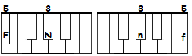

AND (anf), ENDED (FNepcs *or* enf/nf), INDIAN (FNIan), INDIA (FZNIa), INDONESIAN (FNien/ZIan), INDONESIA (FNien/ZIa), INDEED (FNuepcs), SEND (Senf), TEND (FPenf), SECOND (Sepc/ienf), FOUND (Fianf), SOUND (Sianf), FIND (Fuinf).

___________________________________

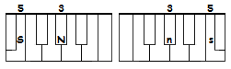Keys **SN** (1st Series) *Sounds:* in. (E/I)NG/end. NG **sn** (4th Series)

ENGINE (SNin *or* ens/n), INGRESS (SNRes), SING (Sins), PING (Pins), KING (CPins), SUNG (Suns), SINGING (Sins/ns)(*).

*As we have seen for the other inflected endings, even in the case of gerund verbal forms, these will be written by adding to the root of the verb the suffix "ng" with a separate stroke.

___________________________________

Keys **FZN** (1st Series) *Sound:* in. (A/E/I)NT/end. NT, N'T (blend) **nzf** (4th Series)

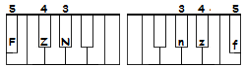

ANTIC (FZNipc), INTEND (FZNenf), INTESTINE (FZNes/FPin), ENTREAT (FZNRuepf), ENTREE (FZNRua), FONT (Fienzf), COUNT (CPianzf), ACCOUNT (apc/cpianzf), CAN'T (CPanzf), CENT (Senzf), SEND (Senzf), DON'T (SCPienzf), QUAINT (CPuanzf).

**Briefs**

and = FN

couldn't = CPienzf

shouldn't = Cienzf

isn't =Snzf

didn't =SCPnzf

**Inflected endings**

^n't = nzf

^ing = ns

**Prefixes and suffixes**

after^ = RXaf

anti^ = anzf/

ante^ = /eanzf

inte^ = FZN(+)(*)

**Punctuation**

{,} = ZN

He sung for a king. Any of you is Indonesian. He opened a second account. He found an antic indian cup. Ned shouldn't hit is son Freddy. He intended to send his son Chris in India. Ada and Diane passed a day finding and singing indian songs.

**Lesson VIII**

keys **SP** (1st Series) *Sound*:in. /end. CH *(soft C)* **ps** (4th Series)

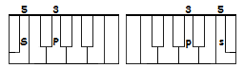

CHECK (SPepc), CKECKING (SPepc/pzf), CHIN (SPin), CHINA (SPuin/a), CHINESE (SPuin/ues), CHOP, (SPiep), CHANGE (SPuans), CHICKEN (SPi/CPen), CHUCK (SPupc), CHUTE (SPuiapf), CHOSE (SPuiez), CHASE (SPuas), TOUCH (FPiaps), TEACH (FPuesp), TECH (FPeps), SUCH (Sups), HATCH (FCaps), HITCH (SPips), PEACH (Pueps), PINCH (PXUips *or* Pin/ps)(**), SEARCH (SReps *or* Sencf/ps) (**), TORCH (FPRieps or FPiencf/ps)(**)

*\*The middle N sound which will be seen in lesson IX.*

*\*\*To obtain the RCH and NCH sounds the R and N sounds can be anticipated and folded in the 2nd Series (if empty), or the «CH» sound can be written as a separate stroke.*

___________________________________

keys **SC** (1st Series) *Sound*: init./end. V **cs** 4th Series

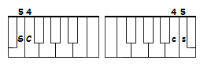

VIP (SCip), VOTE (SCiepf), VEIN (SCuan), VAIN (SCRXuan or SCIuan), VANE (SCean), VANESSA (SCa/Nes/Sa), EVE (uecs), DEV (SCPecs), TV (FPue/SCue), VIVID (SCics/ipcs), PRIVATE (PRuics/apf), SAVE (Suacs), PAVE (Puecs), DAVE (SCPuacs), POSITIVE (Piez/FPics).

___________________________________

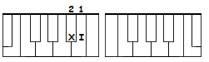keys **XI** (2nd Series) *Sounds*:middle W/F(*)

TWIN (FPXIin), TWO (FPXIie), TWEAK (FPXIuepc), TWEET (FPXIuepf), TWEEN (FPXIuen), SWEAT (SXIepf).

(*) The combinations with double sounds in the 2nd series are used to represent the main similar phonemes; some of them in the Michela-English theory are mainly used for abbreviations.

___________________________________

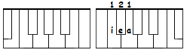

keys **iea** (3rd Series) *Sounds*: OA, OO (disamb.)

FOOD (ieapcs), TOO (FPiea), CHOOSE (SPieaz), SOON (Siean), TOOK (FPieapc), FOOT (Fieapf), PROOF (PRieaf), TROOP (FPRieap), APPROACH (a/PRieaps *or* (ap/PRieaps), COAST (CPieacf), SOAP (Sieap), COAT (CPieapf), COACH (CPieaps).

**briefs**

approach = PRieaps

have = SC

having = SCns

positive = Pics

private = PXIapf

he was = FCXIaz

into = FZNiea

**punctuation**

{?} = PSsp

A Senate vote for increasing inside assets. Two twins sent a few tweets from a hideout to update Dave. Fred did such a fake change. Dave and Eve have a chronic vein of happyness. Vanessa sent to Eve a vain tweet. China has signed a positive peace treaty. Did Dave chose to teach as a coach?

**Lesson IX**

keys **SZ** (lst Series) *Sounds*:in. (A-O)RT, ORD /end. RD **zs** (4th Series)

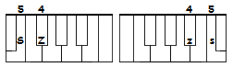

ARTISAN (SZXan), ORDERED (SZRepcs), ORDAIN (SZuan), CARD (CPazs), NERD (Nezs), FORD (Fiezs), CHORD (SPiezs) (*).

*\*The digraph «CH» in this word is written orthographically and not as it should sounds to differentiate it from the words «cord».*

___________________________________

keys **SCN** (lst Series) *Sounds in./end. L* **ncs** (4th Series)

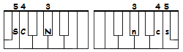

LEAVE (SCNecs), LIVE (SCNics), LET (SCNepf), LEO (SCNIie), LOT (SCNiepf), LISA (SCNue/Sa), LIGHT (SCNuipf), LAST (SCNacf), LIST (SCNicf), SELL (Sencs), VILE (SCuincs), VILLA (SCincs/a; SCincs/SCNa), ALASKA (ancs/as/PCa), LORD (SCNiezs), ALLY (ancs/SCNi), LENS (SCNen/z)(*), NAIL (Nuancs), FAIL (Fuancs), LOLLIPOP (SCNiencs/i/Piep), TAIL (FPiancs), TALE (FPeancs),(*) ALL (ieancs), ONLINE (iean/SCNuin), ALLY (ancs/SCNi), ALLIANCE (ancs/SCNuin/s or ancs/SCNXuin), POLL (Piencs), ALASKA (ancs/as/PCa), LEPTIC (SCNep/FPipc), LATIN (SCNapf/in), LAPIS (SCNap/is), INDIVIDUAL (inf/SCi/SCPUancs), CANCEL (CPan/Sencs *or* CPXencs), CANCELED (CPXencs/pcs), FULL (Funcs), FALL (Fancs), TWELVE (FPXIencs/cs)(*),PEOPLE (Puep/ncs) (*).

*As seen above, some ending blends are not present in the 4th Series, like in these cases with the word endings "NS", "LVE", and "PLE". These word endings, which will better described in Lesson XVII, are usually written putting the final character/sound in a separate stroke. As we'll see, in some cases is also possible to anticipate in the 2nd Series the first consonant sound of the word ending; e.g. lens = SCNXUez; people = PIUuencs (IU = middle "p" sound shown below).

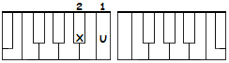keys **XU** (2nd Series) *Sound*:middle N(*)

SNAP (SXUap), SNACK (SXUapc), SNAIL (SXUuancs), ETHNIC (e/FPXUipc *or* RXepf/Nipc), SNATCH (SXUaps), HYPNOTIZE (PXUie/FPuiz)(*).

*The middle N sound, as other 2nd Series sounds, is very useful to create several briefs as shown below.

**briefs**

will = SCN

trascend = SZXenf

druid = SZUipcs

dressed = SZXepcs

Senate = SXuapf

denied = SCPXUuipcs

denoted = SCPXUuiepcs

denial = SCPXUuincs

twelve = FPXIecs *or* FPRIecs

individual = SCPXIipcs/ancs (*or* SCPUancs)

(middle "l" sound shown below, FPRIecs)

tank = FPXUapc

lens = SCNXUez

also = SCNX

**Prefixes & Suffixes**

il^ = incs

^cally = CPRIi

^ful = Fncs

^fulness =FXUs

1

**Punctuation**

{:} = ZNI

{;} = ZNX

Dave is hypnotized from his fiancee. Fred canceled all datas online. Discovered and attacked in his hideout he escaped. A lord in a fine suit ordered a quaint food: fried cow tail. An alliance for saving Alaska tuna fish.

**Lesson X**

keys **ZN** (1st Series) *Sound*:init./end. Y/I **nz** ( 4th Series)

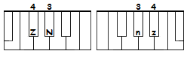

YES (ZNes or ZNe), YEAH (ZNecf), YANKEE (ZNan/CPi), YELL (ZNencs), YELLOW (ZNencs/SCNuie), YEN (ZNen), YESTERDAY (ZNecf/SCPua), YOU'D (upcs), YOU'LL (uncs), YOU'VE (ucs), YUCCA (ZNupc/CPa) YUCATAN (ZNuiapc/FPan) (YOUNG (ZNianf), TOY (FPienz), DESTROY (SCPes/FPRienz), CONVOY (PCien/SCienz), ENVOY (en/SCienz), ANNOY (a/Nienz *or* an/Nienz), DECOY (SCPe/PCienz), IONIAN (ui/uien/ZNan *or* ZNuien/ZNan).

__________________________________

keys **CN** (lst Series) *Sound*:init./end. W/U **nc** (4th Series)

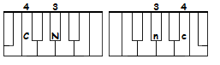

WINE (CNuin), WANT (CNanzf), WATCH (CNaps), WEEK (CNuepc), WIDE (CNuipcs), WRING (CNRinf), WHEAT (CNuepf), WOOSH (CNieac), WAIST (CNuacf), WRIST (CNRicf), WHOSE (CNiez), WITNESS (CNipf/Nes), WHITE (CNuipf), WENDY (CNen/SCPnz), SAW (Sanc), LAW (SCNanc), PAW (Panc), WOW (CNienc), AWFUL (anc/Fncs), DREADFUL (SCPREpcs/Fncs).

__________________________________

**Special inter-series combinations**

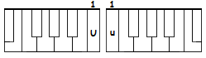

keys **Uu** (2nd+3rd Series)*Sounds*: middle AW, AU

diphthongs

PAWN (Puun), YAWN (ZNUun), LAWN (SCNUun), DRAW(*) (SCPRanc), CRAW(*) (CPRanc), DAWN = SCPUun, LAUD = SCNUupcs, AUDIO (anc/SCPIie).

**This combination is used only when the AW/AU sound is median. In the event of a final syllable, the "W" sound will be written in the 4th Series with the combination described above. In the case of words with the diphthong AW/AU and in which the 2nd and the 4th Series are engaged, will be used the median combination "ia" as a substitute (if no conflicts arise with other words); alternatively the sound "W" can be written with a separate stroke. (e.g. FRAUD = FRiapcs or FRanc / pcs).

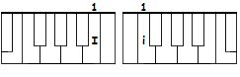

keys **Ii** (2nd+3rd Series)*Sound*: middle OY, OI

diphthongs (**)

VOID (SCIipcs), AVOID (a/SCIipcs), NOISE (NIiz), SOIL (SIincs), CHOICES (SPIips/s), COIN (CPIin), ALLOY (ancs/SCNienz).

**This combination is used only when the OY/OI sound is median. In the event of a final syllable, the "Y" sound will be written in the 4th Series with the combination described above. In the case of words with the diphthong OY/OI and in which the 2nd and the 4th Series are engaged, will be used the median combination "ia" as a substitute (if no conflicts arise with other words); alternatively the sound "Y" can be written with a separate stroke. (e.g. ANDROID = SCPRiapcs *or* SCPRienz/pcs).

__________________________________

**Briefs**

auto = Uapf

what = CNa

with = CN

why = ZN

yes = ZNe

which = CNi

witness = CNXUes

university = CNXUi

would = CNie

where = CN

were = CNR

**Prefixes and suffixes**

auto^ = Uupf

audio^ = Uupcs

**Punctuation**

{-} (hyphen) = FCf

{_} (dash) = SCPc

Why don't you avoid noise, Ned? I chose to drink a yellow wine of Yucatan. It is an awful audio with a dreadful noise. I intend to pass a week in your Ionian house with its tepid sea. Wendy will pass a few weeks at Yale university. Ten and two is twelve. I was checking an autofocus lens at a low light.

**STILL UNDER CONSTRUCTION!**

**We are very sorry, you reached the end of this document... thanks for reading it up here!**

**(since you are here, take a look also at the draft of the prefix and suffix list and at the small dictionary below).**

**APPENDIX**

Prefixes and suffixes

Prefixes

a^ a/ atlas a/tlas (*or* apf/SCNas)

after^ RXaf/ aftermath RXaf/SZPazf

ante^ eanzf/ antedate eanzf/SCPuapf

anti^ anzf/ antisocial anzf/Siancs

audio^ Iupcs/ audiotape Iupcs/FPuap

auto^ Uapf/ automatic Uapf/SZPRIUipc

by^ FCPRXi/ bypass FCPRXi/Pas

comm^ CPRU+ command CPRUanf

con^ CPien/ conflict CPien/FRIipc

con+^ CP+ contest CPRIUecf

counter^ CPRIUencf/ countersign CPRIUencf/Suin

de^ SCPe/ defrost SCPe/FRiecf

enter^ FZNencf/ entertain FZNencf/FPuan

ex^ enzs/ explain enzs/PRIuan

ex+^ SZN exact SZNapc

extra^ SZNRa/ extrajiudicial SZNRa/ZPIiancs

fore^ Fuiencf/ forecast Fuiencf/CPacf

hyper^ FCieap/ hyperactive FCieap/CPRIUics

il^ incs/ illegal incs/SCNXIUancs

inter+^ FZN intend FZNenf

mega^ SZPepzf/ megabyte SZPepzf/FCPuipf

micro^ SZPui/CPRie/ microphone SZPui/CPRie/Fiean

mono^ SZPXUie/ monotone SZPXUie/FPuien

over^ XIencf/ overkill XIencf/CPincs

para^ PRa/ paramedic PRa/SZPRIUipc

post^ Piecf/ postgraduate Piecf/FZPRapcs/CNapf

pseudo^ PXupcs/ pseudonym PXupcs/Nipzs

psycho^ PXuipc/ psychoanalize PXuipc/an/SCNuiz

pro^ PRie/ propose PRie/Puiez

re^ FCNe/ refuel FCNe/FUencs

retro^ FCNRepf/ retroactive FCNRepf/CPRIUics

self^ SRIef/ self-interest SRIef/FZNRecf

semi^ SRUi/ semiannual SRUi/NUancs

sub^ Supcf/ subconscious Supcf/CPias

super^ SIUencf/ superpower SIUencf/PXIencf

trans^ FPRn/ transfusion FPRn/FXien

under^ NRIUencf/ underline NRIUencf/SCNuin

suffixes

^ability /apcf durability SCPRiapcf

^able /pcf durable SCPRapcf

^ably /FCPRIi capably CPuap/FCPRIi

^ache /uapc headache FCepcs/uapc

^age /apz vintage SCinzf/apz

^al /ancs logical SCNXIUipc/ancs

^ally /RIi frantically FRanzf/CPRIi

^ance /ians deliverance SCPRIics/FCNians

^ant /anzf gallant FZPRIanzf

^ard /iapcs bastard FCPas/FPiapcs

^arial /Rancs secretarial Sepzf/FPRancs

^arian /Rian librarian SCNuipcf/FCNian

^arily /FCNRIi primarily PRipzs/FCNRIi

^bility /FCNRIipf flexybility FRIenzs/FCPRIipf

^cally /CPRIi logically SCNiepz/CPRIi

^dly /SCPRIi fixedly Finzs/ SCPRIi

^ed /pcs printed PRinzf/pcs

^en /n lighten SCNuipf/en

^ful /Fncs mindful SZPuinf/Fncs

^fulness /FXUs lawfulness SCNanc/FXUs

^ibility /FCPRIpf ability a/FCPRIpf

^ible /FCPncs visible SCics/FCPncs

^ibly /FCPRIinz possibly Pies/FCPRIinz

^ic /ipc titanic FPRIUan/ipc

^iest /RXecf luckiest SCNupc/RXecf

^ing /ns sending Senf/ns

^ingly /FZPRIi fittingly Fipf/FZPRIi

^ishment /CRUnzf refurbishment FCNe/FRupcf/CRUnzf

^ishness /CXUes sluggishness SRIupzf/CXUes

^ity /FPi nativity Na/FPics/FPi

^iveness /SCXUes positiveness PXipf/SCXUes

^ize /uiaz normalize NRUancs/uiaz

^less /SCNs useless uiaz/SCNs

^lessness /SCNXUes lawlessness SCNanc/SCNXUes

^logical /SCNRIiepz illogical incs/SCNRIiepz

^logically /SCNiepz/CPRIi illogically incs/SCNiepz/CPRIi

^logist /SCNXIUcf geologist ZPue/SCNXIUcf

^ment /SZPnzf sentiment Senzf/SZPnzf

^mental /SZPRIUancs documental SCPiepc/SZPRIUancs

^nal /Nancs exceptional SZNep/CIien/Nancs

^nally /NRIi exceptionally SZNep/CIien/NRIi

^ness /Ns happyness FCeap/Ns

^out /out layout SCNua/RXiapf

^sive /SRXics passive Pas/SRXics

^sy /Si fantasy Fanzf/Si

^tion /Cn foundation Fienf/Cn

^+ction +nzs (or RZ+nzs) traction FPRapzs

^tional /CXUancs intentional FZNen/CXUancs

^tious /Cus cautious CPanz/Cus

^tiousness /CXUs cautiousness CPanz/CXUs

^tual /FPuancs mutual SZPu/FPuancs

^tually /FPRInz mutually SZPu/FPRInz

^ward /CNRpcs forward Fncf/ZNRpcs

^wise /CNXe stepwise SXIUep/CNXe

^xy /SZNi proxy PRie/SZNi

^ard /Rapcs steward SRIUuia/-Rapcs

^cial /CIancs judicial ZPuiapcs/CIancs (*or* ZPIupcs/CIancs)

^cious /Cias vicious SCi/Cias

^+ish +ic danish SCPXUic

Most common English wordlist

(to be continued)

'the': zf

'of': f

'and': anf (*or* FN)

'to': FPie

'a': ua

'in': N

'for': FR

'is': S

'on': ien

'that': FZa

'by': FCPi

'this': FZ

'with': CN

'I': i

'you': u

'it': FP

'not': Niepf

'or': iencf

'be': pcf

'are': R

'from': FRie

'at': apf

'as': az

'your': ZNiancf

'all': RXancs

'have': SC

'new': Nu

'more': SZPiencf

'an': an

'was': CNaz

'we': CNe

'will': SCN

'home': FCuiepzs

'can': CP

'us': us

'about': FCP

'if': F

'page': Puapz

'my': SZPi

'has': FCaz

'search': SReps

'free': FRue

'but': FCPupf

'our': iancf

'one': CNun (*or* Uien)

'other': uiencf

'do': SCPie (*or* SCP)

'no': Nie

'information': FRUiacf

'time': FPuipzs

'they': FZe (*or* FZenz)

'site': Suipf

'he': FCe (*or* e)

'up': up

'may': SZPua

'what': CNa (*or* CNapf)

'which': CNi (*or* CNips)

'their': FZuancf

'news': Nus

'out': iapf

'use': uiaz

'any': Ni

'there': FZR

'see': Sue

'only': NRI (*or* NRIi)

'so': Sie

'his': FCiz

'when': CNen

'contact': CPRIUapc

'here': FCuencf

'business': FCPis

'who': CNie

'web': CNepcf

'also': SCNX (*or* SCNXie)

'now': Nienc (*or* Nia)

'help': FCep

'get': FZPepf

'pm': Ppzs

'view': SCuia

'online': ien/SCNuin

'c': CPRXI

'e': RXIe

'first': FRIcf

'am': apzs

'been': FCPn (or FCPean)

'would': CNie

'how': FCienc

'were': CNR

'me': SZPe

's': SRXI

'services': SXIs/s

'some': Siepzs

'these': FZez

'click': CPRIipc

'its': FPs

'like': SCNuipc

'service': SXIis

'x': SZNRXI

'than': FZan

'find': Fuinf

'price': PRuis

'date': SCPuapf

'back': FCPapc

'top': FPiep

'people': Puep/ncs (or PIUuencs)

'had': FC

'list': SCNicf

'name': Nuapzs

'just': ZPucf

'over': NCXIencf

'state': SRIUuapf

'year': ZNuencf

'day': SCPua

'into': FZNiea

'email': ue/SZPuancs

'two': FPXIie

'health': FCRIezf (*or* FCencs/zf)

'n': NRXI

'world': CNRiencs (*or* CNiencf/SCNpcs

'design': SCPXuin

'happened': FCUIepcs

'witness': CNXUes

'session': SXien

(to be continued)

________________________________